10.85: The speed of the ball just before it hits the bar is 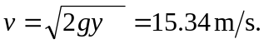
Use conservation of angular momentum to find the angular velocity of the bar just after the collision. Take the axis at the center of the bar.
Immediately after the collsion the bar and both balls are rotating together.
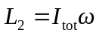
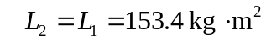
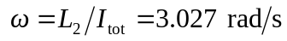
Just after the collision the second ball has linear speed
and is moving upward.
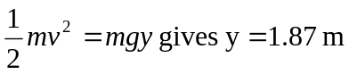for the height the second ball goes.

